**Team 1**

**JavaBots**

**Consider the following schema for Order Database:**

SALESMAN (*Salesman_id, Name, City, Commission*)

CUSTOMER­­1(*Customer_id, Cust_Name, City, Grade, Salesman_id*)

ORDERS (*Ord_No, Purchase_Amt, Ord_Date, Customer_id, Salesman_id*)

**Write SQL queries to**

**1. Count the customers with grades above Bangalore’s average.**

**2. Find the name and numbers of all salesmen who had more than one customer.**

**3: Write an sql query with salesman id, name, customer name from same city , salesman.commission. For salesman having no customer from their city print 'No Match' .At last order all by their descending name of salesman name.**

**4. Create a view that finds the salesman who has the customer with the highest order of a day.**

**5. Demonstrate the DELETE operation by removing salesman with id 1000. All his orders must also be deleted.**

**Table Creation**

CREATE TABLE SALESMAN

(SALESMAN_ID INT(4),

NAME VARCHAR(20),

CITY VARCHAR(20),

COMMISSION VARCHAR(20),

PRIMARY KEY (SALESMAN_ID));

CREATE TABLE CUSTOMER1

(CUSTOMER_ID INT(4),

CUST_NAME VARCHAR (20),

CITY VARCHAR (20),

GRADE int (3),

PRIMARY KEY (CUSTOMER_ID),

SALESMAN_ID INT(4) REFERENCES SALESMAN (SALESMAN_ID) ON DELETE SET NULL);

CREATE TABLE ORDERS

(ORD_NO int (5),

PURCHASE_AMT DECIMAL(10,2),

ORD_DATE DATE,

PRIMARY KEY (ORD_NO),

CUSTOMER_ID INT(4) REFERENCES CUSTOMER1 (CUSTOMER_ID) ON DELETE CASCADE,

SALESMAN_ID INT(4) REFERENCES SALESMAN (SALESMAN_ID) ON DELETE CASCADE);

**Insertion of Values to Tables**

INSERT INTO SALESMAN VALUES (1000, "JOHN","BANGALORE","25 %");

INSERT INTO SALESMAN VALUES (2000, "RAVI","BANGALORE","20 %");

INSERT INTO SALESMAN VALUES (3000, "KUMAR","MYSORE","15 %");

INSERT INTO SALESMAN VALUES (4000, "SMITH","DELHI","30 %");

INSERT INTO SALESMAN VALUES (5000, "HARSHA","HYDRABAD","15%");

INSERT INTO CUSTOMER1 VALUES (10, "PREETHI","BANGALORE", 100, 1000);

INSERT INTO CUSTOMER1 VALUES (11, "VIVEK","MANGALORE", 300, 1000);

INSERT INTO CUSTOMER1 VALUES (12, "BHASKAR","CHENNAI", 400, 2000);

INSERT INTO CUSTOMER1 VALUES (13, "CHETHAN","BANGALORE", 200, 2000);

INSERT INTO CUSTOMER1 VALUES (14, "MAMATHA","BANGALORE", 400, 3000);

INSERT INTO ORDERS VALUES (50, 5000, "04-03-17", 10, 1000);

INSERT INTO ORDERS VALUES (51, 450, "20-01-17", 10, 2000);

INSERT INTO ORDERS VALUES (52, 1000, "24-02-17", 13, 2000);

INSERT INTO ORDERS VALUES (53, 3500, "13-04-17", 14, 3000);

INSERT INTO ORDERS VALUES (54, 550, "09-03-17", 12, 2000);

**Solution**

1. Count the customers with grades above Bangalore’s average.

SELECT GRADE, COUNT(distinct CUSTOMER_ID)

FROM CUSTOMER1

GROUP BY GRADE

HAVING GRADE > (SELECT AVG(GRADE)

FROM CUSTOMER1

WHERE CITY="BANGALORE");

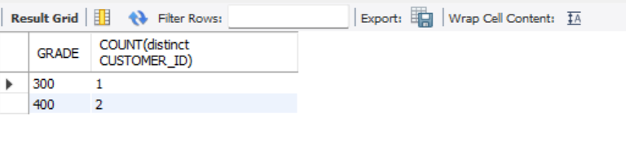

2. Find the name and numbers of all salesmen who had more than one customer.

SELECT SALESMAN_ID, NAME

FROM SALESMAN

WHERE 1 < (SELECT COUNT(*)

FROM CUSTOMER1

WHERE CUSTOMER1.SALESMAN_ID=SALESMAN.SALESMAN_ID);

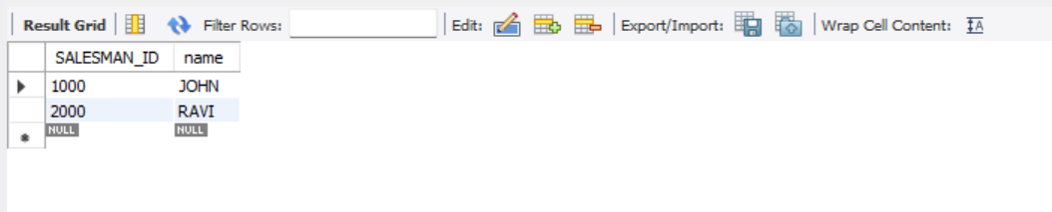

3. List all salesmen and indicate those who have and don”t have customers in their

cities .

SELECT SALESMAN.SALESMAN_ID, NAME, CUST_NAME, COMMISSION

FROM SALESMAN, CUSTOMER1

WHERE SALESMAN.CITY = CUSTOMER1.CITY

UNION

SELECT SALESMAN_ID, NAME, "NO MATCH", COMMISSION

FROM SALESMAN

WHERE NOT CITY = ANY

(SELECT CITY

FROM CUSTOMER1)

ORDER BY 2 DESC;

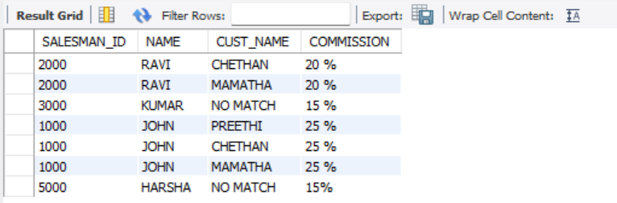

4. Create a view that finds the salesman who has the customer with the highest order

of a day.

CREATE VIEW ELITSALESMAN AS

SELECT B.ORD_DATE, A.SALESMAN_ID, A.NAME

FROM SALESMAN A, ORDERS B

WHERE A.SALESMAN_ID = B.SALESMAN_ID

AND B.PURCHASE_AMT=(SELECT MAX(PURCHASE_AMT)

FROM ORDERS C

WHERE C.ORD_DATE = B.ORD_DATE);

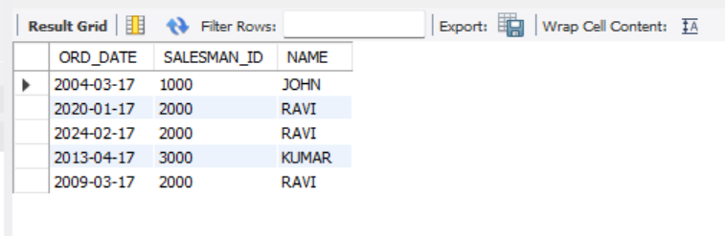

5. Demonstrate the DELETE operation by removing salesman with id 1000. All his orders

must also be deleted.

Use ON DELETE CASCADE at the end of foreign key definitions while creating child table

orders and then execute the following:

Use ON DELETE SET NULL at the end of foreign key definitions while creating child table

customers and then executes the following:

DELETE FROM SALESMAN

WHERE SALESMAN_ID=1000;

